Dear Friends,
If you have seen or heard about the recent Detroit Metro Times article regarding our upcoming June 13 event, I wanted to personally address the situation directly.
Last week, we were contacted by legal counsel representing Coachella regarding the name “Pawchella.” We were informed that they hold a trademark related to the use of “chella” and requested that we remove Pawchella promotions from social media immediately.
First and foremost, I want to reassure you that we would never intentionally violate a trademark. When this event was created more than three years ago, we conducted our own research and genuinely did not know there was a trademark associated with the term. Had we known, we never would have used the name.
As soon as we became aware of the issue, we immediately contacted legal counsel, including a trademark attorney, to fully understand our options and determine the best path forward. After careful consideration, we made the decision to comply with the request because our focus must remain where it belongs: serving our community and helping animals in need. We would rather dedicate our time, energy, and resources toward saving more animals and creating a successful community event than engaging in a legal battle over a name.
During discussions with legal counsel, our attorney requested permission for us to continue using the name through this year’s event, given that it is only a month away and many materials had already been produced. We were granted that request under the condition that we no longer promote “Pawchella” on social media and that the event be rebranded for 2027.
As a result, you will now see the event promoted externally on social media only as the “PAW FEST.” However, all printed materials, including raffle tickets, flyers, yard signs, and merchandise, TV, and radio, will still reference Pawchella.
While the name may evolve, the heart of this event has never changed. This event was always about bringing people, community, and animals together for a meaningful cause.
We hope you will come out on June 13 to support the animals and help make this event a success. Your support matters now more than ever.
There are many ways you can get involved:
● Attend the event on June 13
● Purchase raffle tickets available at all 14 Premier Pet Supply locations or at our shelter
● Purchase one of our limited-edition event t-shirts (which now may become collector’s items) and receive free admission to the festival
● Display a yard sign to help spread awareness throughout the community
● Spread our message and updates leading up to the event so we can have the biggest turnout ever.
Additionally, we will be inviting our community soon to help us rebrand the event for next year. We would love your input and creativity as we work together to choose a new name that reflects the spirit of this incredible event. We will plan to narrow submissions down to a “top three,” and allow the community to vote after the event this year.
I cannot thank you enough for your continued support, understanding, and belief in our mission. We are a small animal shelter doing everything we can to serve the people and animals who depend on us, and we are incredibly grateful to have a community standing beside us.
I look forward to seeing you on June 13.
Together, we can turn this into something positive and continue helping more animals in need.
With gratitude,
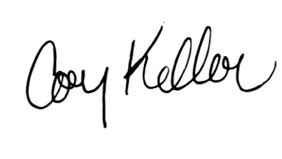
Cory Keller
President & CEO
Friends for Animals of Metro Detroit

